CONSTITUTION AND BYLAWS

ARTICLE I - NAME

The name of this golf club shall be Space Golf Club, hereafter referred to as SGC or the Club.

ARTICLE II - PURPOSES

The purpose of this club is to bring together a group of people who desire to form a golfing organization:

(1) To promote and foster among its members a closer bond for their mutual benefit;

(2) To promote and conserve the best interests and true spirit of the game of golf as embodied in its ancient and honorable traditions;

(3) To enforce uniformity in the rules of the game by creating a representative authority;

(4) To maintain a uniform system of handicapping as set forth in the regulations of the United States Golf Association; and

(5) To afford a convenient and authoritative body to organize and conduct Club tournaments held at regulation golf courses for the benefit of the Club members.

ARTICLE III - MEMBERSHIP

Section 1. Membership shall be available to (all men/women over the age of 18 years old). Membership shall be available to member's dependents under 18 years old as Junior Members.

Section 2. SGC memberships are individual and non-transferable.

Section 3.

Section 4.

Section 5. Memberships in the Club are for a year only, with all memberships expiring on their individual anniversary date.

Section 6. Each candidate for membership shall submit an application to the SGC Membership Chairman for processing or presentation to the Board of Officers. Approval for membership requires a minimum of two positive votes from the Board. Rejection for membership requires a minimum of two negative votes from the Board.

Section 7. In the event any SGC member commits an act which reflects discredit or disrepute on the SGC or refuses or neglects to comply with the Constitution and Bylaws, the member will be subject to suspension or expulsion. This action requires a vote of two-thirds of the Board of Officers at any regular meeting or special meeting called for that purpose. The action will be documented in writing by the President, citing the exact reason for the action taken. The affected member has the right to be heard by the Board for potential reinstatement, but he/she must notify the Board within ten days of his/her notification.

Section 8. All membership fees and dues shall be established by the Board of Officers from time to time in an amount which they deem to be adequate to operate and maintain the SGC. Members will be dropped from Club membership if dues are not paid before their expiration date.

ARTICLE IV - BOARD OF OFFICERS

Section 1. The SGC Officers shall consist of four elected members (President, Vice President, Secretary, and Treasurer) and they shall exercise all powers of management in the Club not specifically excepted by these bylaws. The Board of Officers shall consist of the SGC Officers plus the Committee Chairpersons and active past presidents.

Section 2. SGC elections of Officers will be conducted in the first week of December in years that they are required. At least five weeks prior to the election, the Board of Officers shall appoint a Nominating Committee. At least four weeks prior to this election, this Committee will submit to the Board, a list of nominees to fill any vacancies for the term of office. Names of other members in good standing may be nominated by petition signed by at least ten members and submitted to the Board at least three weeks prior to the election. At least two weeks prior to the election date, a list of all candidates nominated and a ballot shall be provided to each member

Ballots must be returned to the Club Secretary and must be received by the election date to be considered. The Nominating Committee will compile the election results and report them to the Board.

Section 3. The term of office for any elected officer will be two years. The term will commence on January 1.

Section 4. The governing Board of Officers shall meet at appropriate times and places as they may select to conduct the Club’s business, and a majority of the Board shall constitute a quorum at any meeting.

Section 5. In the case on any vacancy, the remaining Officers, even though less than a quorum, may elect a successor by majority vote to hold office for the unexpired term of the Officer, and until the election of a successor.

ARTICLE V - OFFICERS AND COMMITTEES

Section 1. The SGC Officers shall consist of President, Vice-President, Secretary, and Treasurer; and their duties shall be such as their title would indicate or such as may be assigned to them respectively from time to time by the President. The SGC Officers will be responsible for conducting routine business of the Club in support of the Club’s Purposes.

President - The President will preside at meetings of the Board and serve as a member
of all committees.

Vice- President - The Vice President will perform the duties of the President in his absence and perform other duties that may be prescribed by the Board.

Secretary - The Secretary will record, transcribe, and distribute, minutes of all Board meetings.

Treasurer - The Treasurer will keep records of Club finances ,summarize them monthly, and report them at each Board meeting. The Treasurer will be responsible for Club bank accounts and payment of accounts due as authorized by the Board of Officers. The Treasurer shall be responsible for the accounting of tournament prizes. The fiscal year for the Club will be the calendar year. In the event of dissolution of the Club, net assets will be distributed to the members.

Section 2. The SGC Officers shall authorize and define the powers and duties of all committees. Chairpersons and members of all committees shall be appointed by mutual consent, and the President shall be an ex-officio member of all committees except the nominating committee.

Section 3. The following chairpersons and/or committees will be appointed; others may be appointed as the President deems necessary or advisable:

Tournament Chairperson to arrange and schedule competitions with golf course management. Tournament Directors will be designated by the Board and will be responsible for conducting the competitions;

Handicap Chairperson to establish and maintain a fair and proper system of handicaps in accordance with procedures laid down by the United States Golf Association;

Membership Chairperson to act upon all applications for membership;

Rules Chairperson to assist players in understanding golf rules and to provide interpretations and rulings resulting from tournament or other play, and to ensure golfers are playing by USGA golf rules;

Website Curator to maintain the club’s website.

SCGA Delegate to represent the Club at SCGA Delegate meetings.

ARTICLE VI - AMENDMENTS TO BYLAWS

Section 1. The Board of Officers shall have the power to repeal or amend any of the attached Bylaws.

AMENDMENT 7.0
November 16, 2025
The Constitution and Bylaws presented here is a modification from the Amendment 6.0 dated October 14, 2024 (signed by Badgley/Martinez/Fagan/Thoeny)
Signed:
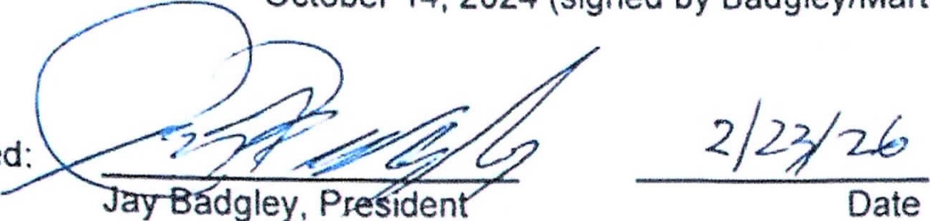
Iden

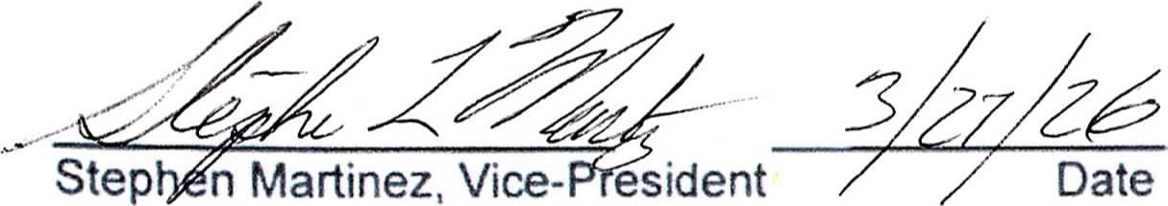
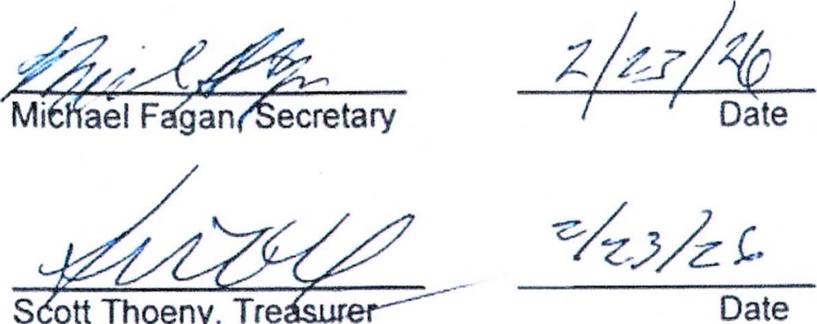
S
Ott
Thoeny,
Tre

SPACE GOLF CLUB

BYLAWS

The following rules have been proposed and adopted by the SGC Board of Officers and shall remain in effect until revised or deleted by vote of a majority of the Board.

1. CLUB CHAMPIONSHIPS

SGC Club champions - A men’s and a women’s SGC Club champion will be selected based on play in a low net tournament. The Club Championship will be determined each year by competition within a regularly scheduled tournament. To be eligible for the Championship, a member must have played in at least 1/3 of the club tournaments with the number rounded down to the nearest whole number, eg. for 14 total tournaments, 1/3 would be 4 and 2/3 so 4 would be the number of tournaments to be eligible, or won a tournament during the previous calendar year. Also, to have a woman champion for the club there must be at least two eligible women who compete in the club championship tournament.

Tournament of Club Champions Entry - A candidate to play in the SCGA Annual Tournament of Club Champions will be selected based on gross scores in SGC tournaments during the period between October 1 and September 30 each year. All SGC members will compete for these points, regardless of their flight. The Club will sponsor one representative at the SCGA TOCC.

At each BSGC tournament, members earn points based on their gross scores:
Low gross | 3 points
Second low | 2 points
Third low | 1 point

The member who has earned the most points during the year ending September 30 will have the opportunity to compete in the SCGA Tournament of Club Champions as the SGC representative. Should that member be unable to compete, the member with the next highest point total will qualify to represent SGC, etc.

SCGA 4-Ball Tournament Entry – Partners to play in the SCGA annual 4-Ball Tournament will be selected using the SCGA format at one of the Club’s regularly scheduled tournaments

2. GUEST FLIGHT HANDICAP: SGC has adopted the Callaway handicap system for guests or members without a USGA sanctioned handicap who participate in SGC tournaments.

3. MULTIPLE SCGA MEMBERSHIP: Full membership fees are due the SGC regardless of affiliation with another SCGA Club. Membership fees will be adjusted to reflect actual SCGA membership charges to the SGC plus club operating fees.

5. UNCLAIMED PRIZE DISTRIBUTION: All prizes will be valid for a period of two years from date of issue. All unclaimed prizes will become the property of the SGC and cash due will be placed into the SGC Treasury.

- TOURNAMENT DIRECTOR’S EXPENSE: Tournament Director’s Green Fees and 1/2 Cart Fee is allowed. Individual tournament Golf Fees and Golf Cart allowances shall be paid for by the Club. All other expenses allowed, Hospitality, etc. shall be paid for out of the SGC Treasury. The SGC will not reimburse rooming expenses.

7. WINTER / SUMMER RULES: Since there is no definition of "Winter Rules," the SGC has elected to follow those recommendations made by in the USGA Rule Book by PLAYING THE BALL AS IT LIES. The exception occurs when extreme weather conditions or Course local rules dictate a change of policy. Prior to start of play, if such weather conditions prevail, the Tournament Director, in conjunction with Course Officials, shall make a determination of applicable special rules.

8. SCGA MEMBERSHIP: The SGC (and its membership) will be a member of the SCGA and abide by it’s rules and regulations. SGC will use the SCGA to determine handicaps for the Club membership and take advantage of other benefits offered by that organization.

9.
10. RULINGS DURING TOURNAMENTS - The Rules Chairman will normally make rulings on interpretation of the Rules of Golf. If a decision warrants it, he/she or the Tournament Director may assemble a committee of three Board members to make a ruling.

